5 PEN PC TECHNOLOGY
N. Manikanta, narayanadasmanikanta2@gmail.com, +6281433395

- INTRODUCTION
Communication Technology is rapidly increasing in this modern world. Computer, as everybody knows, is the main communication machine used. Since the time computer has been invented scientists and engineers have been trying making it more and more compact. As a result we have been able to enjoy the numerous functionalities provided by the computers whether it is Home PCs or Laptops. Systems have still been reduced so that they are used in Mobiles I-pods and I-phones have replaced the laptops to an extent. It is in this context that Pen Computers come into spotlight. These are computers in the shape of different pens each having a function of its own and when combined together give us the usage of a full-blown computer. It is a computer broken apart into pieces, each the size of a pen. The screen and keyboard are projected onto surfaces.
- Are they pens with cameras?
P-ISM (“Pen-style Personal Networking Gadget Package”), which is nothing but the new discovery, which is under

Developing, stage by NEC Corporation. P-ISM is a gadget package including five functions.
A pen-style cellular phone with a handwriting data input function, virtual keyboard, a very small projector, camera scanner, and personal ID key with cashless pass function. P-ISMs are connected with one another through short-range wireless technology. The whole set is also connected to the Internet through the cellular phone function. This personal gadget in a minimalist pen. Style enables the ultimate ubiquitous computing.
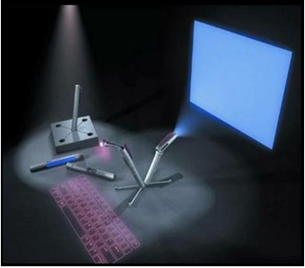
Figure 1.1:5 Pen pc technology

- P-ISM
P-ISM “Pen-style Personal Networking Gadget Package”. P-ISM is a gadget package including five functions

- CPU PEN
- COMMUNICATION PEN
- KEY BOARD
- CAMERA
- DISPLAY

Block diagram of P-ISM
P-ISMs are connected with one another through short-range wireless technology. The whole set is also connected to the Internet through the cellular phone function.
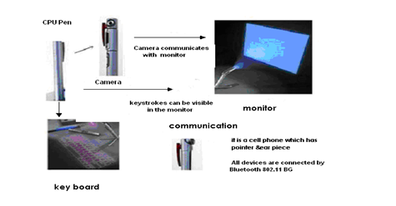
Figure 1.3:Block diagram of P-ISM

They are connected through Tri-wireless modes (Blue tooth, 802.11B/G, and Cellular) which are made small and kept in a small pen like device.

- CPU PEN
The functionality of the CPU is done by one of the pen. It is also known as computing engine. It consists of dual core processor embedded in it and it works with WINDOWS operating system. The central processing unit (CPU) is the portion of a computer system that carries out the instructions of a computer program, and is the primary element carrying out the computer’s functions. The central processing unit carries out each instruction of the program in sequence, to perform the basic arithmetical, logical, and input/output operations of the system.

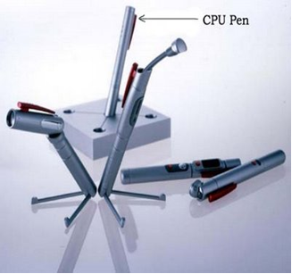
Figure 3.1: CPU Pen

This term has been in use in the computer industry at least since the early 1960s. The form, design and implementation of CPUs have changed dramatically since the earliest examples, but their fundamental operation remains much the same. Early CPUs were custom-designed as a part of a larger, sometimes one-of-a-kind, and computer. However, this costly method of designing custom CPUs for a particular application has largely given way to the development of mass-produced processors that are made for one or many purposes.
This standardization trend generally began in the era of discrete transits or mainframes and mini computers and has rapidly accelerated with the popularization of the integrated circuit(IC). The IC has allowed increasingly complex CPUs to be designed and manufactured to tolerances on the order of nanometers.
Both the miniaturization and standardization of CPUs have increased the presence of these digital devices in modern life far beyond the limited application of dedicated computing machines. Modern microprocessors appear in everything from automobiles to cell phones and children's toys.

- COMMUNICATION PEN
P-ISM’s are connected with one another through short-range wireless technology. The whole set is also connected to the Internet through the cellular phone function. They are connected through Tri-wireless modes (Blue tooth, 802.11B/Gland terabytes of data, exceeding the capacity of today’s hard disks.
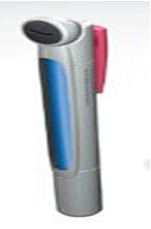
Figure 3.1: Communication Pen
This is very effective because we can able to connect whenever we need without having wires. They are used at the frequency band of 2.4 GHz ISM (although they use different access mechanisms). Blue tooth mechanism is used for exchanging signal status information between two devices.
This techniques have been developed that do not require communication between the two devices (such as Blue tooth’s Adaptive Frequency Hopping), the most efficient and comprehensive solution for the most serious problems can be accomplished by silicon vendors. They can implement information exchange capabilities within the designs of the Blue tooth.
- BLUETOOTH
Bluetooth uses a radio technology called frequency-hopping spread spectrum, which chops up the data being sent and transmits chunks of it on up to 79 bands (1 MHz each; centered from 2402 to 2480 MHz) in the range 2,400-2,483.5 MHz (allowing for guard bands).
In the simple case of single-slot packets the master transmits in even slots and receives in odd slots; the slave, conversely, receives in even slots and transmits in odd slots. Packets may be 1, 3 or 5 slots long but in all cases the master transmits will begin in even slots and the slave transmits in odd slots.
Bluetooth provides a secure way to connect and exchange information between devices such as faxes, mobile phones, telephones, laptops, personal computers, printers, Global Positioning System (GPS) receivers, digital cameras, and video game consoles.
At any given time, data can be transferred between the master and one other device (except for the little-used broadcast mode). The master chooses which slave device to address; typically, it switches rapidly from one device to another in a round-robin fashion.
The Bluetooth Core Specification provides for the connection of two or more picots to form scatter net, in which certain devices serve as bridges, simultaneously playing the master role in one pica ate and the slave role in another.
Bluetooth Radio incarnation. Such devices can link computers with Bluetooth with a distance of 100 meters, but they do not offer as many services as modern adapters do.

- CELLULAR NETWORK
A cellular network is a radio network distributed over land areas called cells, each served by at least one fixed-location transceiver known as a cell siteor base station. When joined together these cells provide radio coverage over a wide geographic area. This enables a large number of portable transceivers (e.g., mobile phones, pagers, etc.) to communicate with each other and with fixed transceivers and telephones anywhere in the network, via base stations, even if some of the transceivers are moving through more than one cell during transmission.
Cellular networks offer a number of advantages over alternative solutions:
- Increased capacity
- Reduced power use
- Larger coverage area
- Reduced interference from other signals
An example of a simple non-telephone cellular system is an old taxi driver’s radio system where the taxi company has several transmitters based around a city that can communicate directly with each taxi.
In a cellular radio system, a land area to be supplied with radio service is divided into regular shaped cells, which can be hexagonal, square, circular or some other irregular shapes, although hexagonal cells are conventional.

- VIRTUAL KEYBOARD
The Virtual Laser Keyboard (VKB) is the ULTIMATE new gadget for PC users. The VKB emits laser on to the desk where it looks like the keyboard having QWERTY arrangement of keys i.e., it uses a laser beam to generate a full-size perfectly operating laser keyboard that smoothly connects to of PC and most of the handheld devices. As we type on the laser projection, it analyses what we are typing according to the co-ordinates of the location.
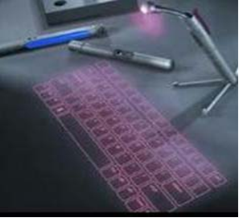
Figure 4.1: Virtual keyboard
A virtual keyboard is a software component that allows a user to enter characters. A virtual keyboard can usually be operated with multiple input devices, which may include a touch screen, an actual keyboard, computer mouse, ahead mouse and an eye mouse.
- DIGITAL CAMERA
The digital camera is in the shape of pen .It is useful in video recording, video conferencing, simply it is called as web cam. It is also connected with other devices through Blue tooth. It isa 360 degrees visual communication device. This terminal will enable us to know about the surrounding atmosphere and group to group communication with a round display and central super wide angle camera.
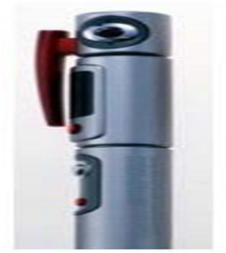
Figure 6.1: Digital camera
A digital camera (or digital) is a camera that takes videos still photographs, or both, digitally by recording images via an electronic image sensor. Most 21st century cameras are digital. Front and back of Canon Powers hot A95 Digital cameras can do things film cameras cannot: displaying images on a screen immediately after they are recorded, storing thousands of images on a single small memory device, and deleting images to free storage space.
The majority, including most compact cameras, can record moving video with sound as well as still photographs. Some can crop and stitch pictures and performs other elementary image editing. Some have a GPS receiver built in, and can produce Geotagged photographs. The optical system works the same as in film cameras, typically using a lens with a variable diaphragm to focus light onto an image pickup device.
The diaphragm and shutter admit the correct amount of light to the imager, just as with film but the image pickup device is an electronic rather than chemical. Most digitals, apart from camera phones and a few specialized types, have a standard tripod screw. Digital cameras are incorporated into many devices ranging from PDAs and mobile phones (called camera phones) to vehicles. The Hubble Space Telescope and other astronomical devices are essentially specialized digital cameras.

- LED PROJECTOR
The role of monitor is taken by LED Projector which projects on the screen. The size of the projector is of A4 size. It has the approximate resolution capacity of 1024 X 768. Thus it is gives more clarity and good picture. Fig: diagram of led projector a video projector is a device that receives video signal and projects the corresponding image on a projection screen using a lens system.

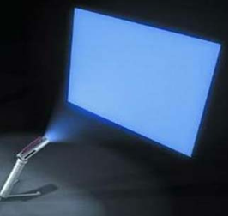
Figure 7.1: Led Projector

All video projectors use a very bright light to project the image, and most modern ones can correct any curves, blurriness, and other inconsistencies through manual settings. Video projectors are widely used for conference room presentations, classroom training, and home theatre and live events applications. Projectors are widely used in many schools and other educational settings, connected to an interactive whiteboard to interactively teach pupils.

- BATTERY
The most important part in portable type of computer is battery and storage capacity. Usually batteries must be small in size and work for longer time. For normal use it can be used for 2weeks. The type of battery used here is lithium ion battery. The storage device is of the type tubular holographic which is capable of storing. The use of lithium ion battery in this gadget will reduce energy density, durability and cost factor. By making Five Pen PC feasible, it will enable ubiquitous computing therefore it is easier for people to use. Many applications can be imagined with this new technology.
As it makes use of E-fingerprinting the gadget will be more secure, which allows only owner to activate thence. So even if we lose it, no one else call access the gadget. All PC’s communicate each other with the help of Bluetooth technology and the entire gadget is connected to internet (Wi-Fi).This technology is very portable, feasible and efficient.
Everybody can use this technology in very efficient manner. Some prototypes have been already developed in 2003 which are very feasible, but currently unclear. The enhancement in this technology can be expected in coming years.

IV. ADVANTAGES AND DISADVANTAGES
8.1 ADVANTAGES:
- Portable
- Feasible
- Ubiquitous
- Makes use of Wi-Fi technology
8.2 DISADVANTAGES:
- Currently unclear
- Cost
- Keyboard concept is not new
- Easily misplaced as the gadget is very costly the consumer cannot afford to purchase them
- The virtual keyboards are already present in various companies like Lummi and Virtual Devices Inc.
- CONCLUSION
The communication devices are becoming smaller and compact. This 'pen sort of instrument' produces both the monitor as well as the keyboard on any flat surfaces from where you can carry out functions you would normally do on your desktop computer.. It is simply a new invention in computer and it is associated with communication field. Surely this will have great impact on the computer field. In this device you will find Bluetooth as the main interconnecting device between different peripherals. This is only an example for the start of this new technology. We can expect more such developments in the future. It is a computer broken apart into pieces, each the size of a pen. The screen and keyboard are projected onto surfaces. The advantages of this technology are it is portable, Feasible, Ubiquitous, Makes use of Wi-Fi technology.

